**Amazon Web Services**

-By Shubham Krishna

# **AWS Cloud Essentials**

## **AWS vs Customer responsibilities**

* Shared responsibility principle

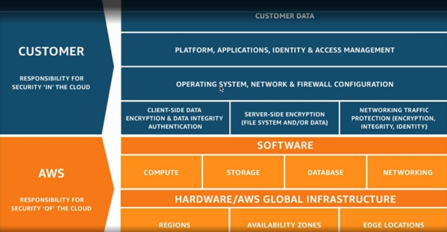

Customer responsibilities:

* OS updates
* Backups
* Firewalls
* Maintainence schedules
* Application security (eg. Sql injections)

Related courses-

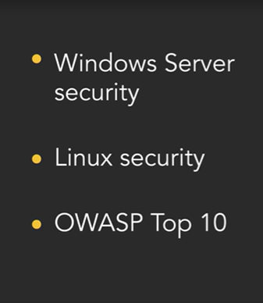

## **Identity and Access Management:**

* Documentation: [AWS Identity and Access Management Documentation](https://docs.aws.amazon.com/iam/)
* Minimize the use of root accounts. Only root user can delete AWS accounts.
* Create user groups and add users.
* Assign policies to limit access/privileges to the AWS account.
* ARN(Amazon Resource Names): Unique id which is assigned to all the resources in AWS. This is used to link the various resources in cloud infrastructure together.
* AWS IAM Identity center: It can be configured to have Single sign on feature if company uses Microsoft active deirectory.

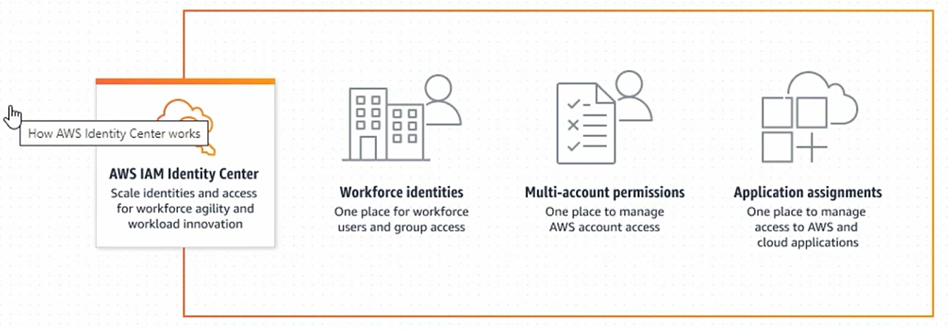

* AWS Organisations: Best way to manage multiple AWS root account.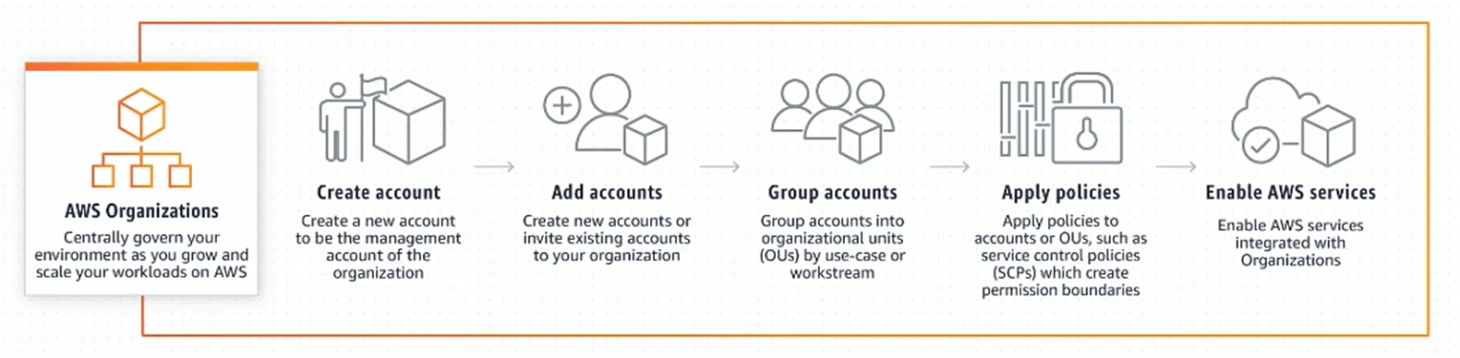

## **Elastic cloud compute(IaaS compute)**

* AWS cloud servers
* AWS marketplace allows us to find preconfigured EC2 instances from thirdparty vendors with or without additional licensing fees.
* There are various instance types:

[Cloud Compute Instances – Amazon EC2 Instance Types – AWS](https://aws.amazon.com/ec2/instance-types/)

* Stopping and Starting the EC2 instance will move the host to different physical server in availability zone. Whereas Rebooting the instance will be carried upon same physical server.
* Auto scaling
* Vertical scaling: Stop the EC2 instance and change the server to faster processor and more RAM.
* Horizontal scaling: Multiple servers are created to handle the traffic. For eg. Opening mulitple queues in banks for cash transactions and when rush is reduced the queues are closed.
* AMI(Amazon Machine Image) is great technique to create snapshots of existing virtual machines with its configuration and it can be used for scaling. Unless No reboot is specified the existing server instance will be rebooted while creating the AMI.

## **IaaS Networking**

* Security groups act as Firewalls for servers on cloud.
* Virtual Private cloud allows the EC2 servers to communicate privately with each other without traversing the public internet.
* Subnet is a group of sequential ip addresses and it provides ways to divide the network of available ip addresses into smaller buckets so that we can apply networking rules to these groups separately.
* NAT gateway will have door know from inside. Internet gateways will have door knob from inside and outside.
* Elastic ip are fixed ip for EC2 instance.
* Elastic load balancer is an importatnt component that enables horizontal scaling in AWS. Application load balancer can balance the traffic to healthy webservers.
* Route53 is the DNS server hosted by AWS.
* Secure way of connecting to EC2 instance- Bastion host, Client VPN, Session Manager.

## **IaaS Storage**

* Elastic Block Store- it can stretch in size when needed.
* We can create EBS volumes and mount them to running instaces. This will act as additional hard drives to our instaces. It will store OS, app source codes.
* One limitation is once EBS voulme is mounted to an EC2 instance, it can’t be mounted to another instances. Sharing of files between instances is not possible with EBS volumes.
* Elastic File System(EFS) allows us to mount and share files across multiple instances. It will store user uploaded data. Not as fast as EBS. EFS is supported for only linux instances.
* Simple storage service doesn’t require server/file system configurations. S3 is slower than EBS and EFS. **Transfer accelerator** can be used to upload large files to S3 buckets.
* IAM roles can be used to prevent using access keys and secrets in server source codes.

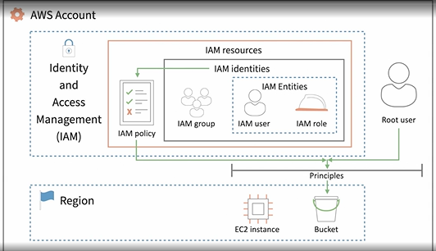

* AWS secrets manager stores the access keys and secrets which can be used in scenarios where we have to pass the credentials to external 3rd party services which are not AWS services.
* S3 glaciers are cheapest data storage which can be used for data which not used frequently.
* CloudFront is a content delivery network using which we can push the contents of S3 buckets to edge servers all over the world.
* **Global accelerator** can be used to clone applications into multiple regions for global access when EC2 instances are created in single region.

## **DataBase as a Service(DBaaS)**

* Data Migration service can be used to create in sync clone of on premise database to cloud.
* Points to consider for choosing DB:

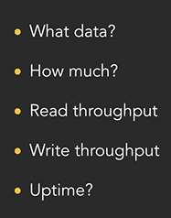

* Relational Database service to create relational databases on cloud.
* Amazon Aurora can take care of database management tasks. Also managing scaling or database administration tasks.
* DynamoDB and DocumentDB are full managed NoSQL database service.

|  |  |  |
| --- | --- | --- |
| **Feature** | **Amazon DynamoDB** | **Amazon DocumentDB** |
| **Data Model** | Key-Value and Document-Based | Document-Based (MongoDB-compatible) |
| **Compatibility** | NoSQL with flexible schema; not MongoDB compatible | MongoDB-compatible API, drivers, and tools |
| **Primary Use Case** | High-throughput, low-latency applications (e.g., IoT, gaming, mobile apps) | Document-based applications (e.g., CMS, user profiles, real-time analytics) |
| **Scalability** | Automatic horizontal scaling, handles large amounts of data | Horizontal scaling, read replicas for scaling reads |
| **Query Capabilities** | Simple queries with primary key and secondary indexes | Advanced querying with MongoDB-like query syntax, aggregation, and indexing |
| **Data Storage** | Table with rows (items) and columns (attributes) | Collection of JSON-like documents |
| **Consistency** | Eventual consistency (default), strong consistency (optional) | Strong consistency, with automatic replication for high availability |
| **Indexing** | Supports Global Secondary Indexes (GSI) and Local Secondary Indexes (LSI) | Supports secondary indexes, including compound and hashed indexes |
| **Security** | Encryption at rest and in transit, IAM integration for access control | Encryption at rest and in transit, IAM integration, VPC support |
| **Management** | Fully managed, automatic scaling, backups, and patching | Fully managed, automatic backups, multi-AZ deployment, patching |
| **Performance** | Low-latency, high-throughput performance with predictable response times | Low-latency performance with support for complex queries and large data sets |
| **Backup and Restore** | Automated backups and Point-In-Time Recovery (PITR) | Automated backups and Point-In-Time Recovery (PITR) |
| **Pricing** | Based on read/write capacity, storage, and optional features (e.g., Streams) | Based on instance size, storage, I/O operations, and data transfer |
| **Integration with AWS** | Integrates with AWS Lambda, S3, Redshift, and others | Integrates with AWS Lambda, CloudWatch, S3, Glue, etc. |
| **Use Cases** | Real-time applications (gaming, IoT, mobile apps), session management | Content management systems, product catalogs, real-time analytics, user profiles |

* ElastiCache helps to manage and deploy in-memory caches (Redis, Memcached).
* Amazon Redshift is used to search and report data from large data warehouses.
* Kinesis and Simple Queue Service is used to buffer data before it can be written in DB and enables data search. Simple Notification service is used to send notifications.

## **Platform as a Service**

* Amazon Elastic Beanstalk is a fully managed Platform-as-a-Service (PaaS) offering from AWS that simplifies the deployment, management, and scaling of applications.
* It manages the underlying hardware, servers, or network infrastructure.
* Elastic container service is container orchestration tool in AWS.
* Elastic container registery
* EC2 instance(always running), Fargate(on demand), External(on premise server) are options.
* Amazon Elastic Kubernetes service.
* AWS lamda- Run code without thinking about servers. Funtion as a service.

Server less architecture.

* AWS Batch
* EC2 spot instances.
* AWS step functions.

## **Software as a Service**

* Software that runs in cloud and you don’t have to write code or maintain.
* Cognito allows sign-in integrations with other providers like google or faceboot authentications.
* Amazon API gateway is a way to publish REST API endpoints for each of microservices and point them at various AWS services.
* AWS AppSync is used to build scalable and secure GraphQL APIs for mobile, web, and enterprise applications.
* AWS X-Ray is used to trackdown errors and slow downs in the system.
* AWS SageMaker is used to build and train machine learning models.
* AWS Comprehend for sentiment analysis.
* AWS Lex to create chatbots.
* AWS Personalize to recommend products based on customer data analysis.
* AWS Polly to read texts.
* AWS Recognition and TextRact for extracting images and texts.
* AWS Translate to detect and translate languages.
* AWS Transcribe to transcribe texts.

## **DevOps with AWS**

* Code Pipeline enables continous integration.
* Code Deploy enables continuos deployment.
* AWS Cloud formation, Terraform(Multi cloud deployment)- Infrastructure as code
* AWS Cloudwatch is used to monitor the cloud infrastructure. Application performance monitoring. It can detect problems after it has occurred.
* AWS DevOps Guru uses ML and notifies if things are out of place.
* AWS CodeGuru can review the code.

## **Security on AWS**

* Web Application Firewall(WAF) can connect to load balancer to mitigate attacks, rules which can be subscribed.
* Shield to denial service attacks.
* Guard duty can find suspicous server networks.
* Inspector can find common security vulnerabilities. Full virus scan.
* GuardDuty can actively scan your entire AWS account for suspicious traffic to detect a breach, whereas the Inspector agent can periodically scan your EC2 instances to check for vulnerabilities to prevent a breach.
* Macie will look into Amazon S3 buckets for sensitive data(PII, Financial data, IP and other sensitive/regualtory complainace data) which has been made public. It does data discovery, data classification and provides insights and alerts.
* AWS Systems manager
* CloudTrail is an audit trail in AWS accounts.
* AWS Security hub – one place for all security products.
* AWS detective which AWS users/resources making suspicious API calls.

# **AWS Machine Learning Essentials**

## **What algorithms to use?**

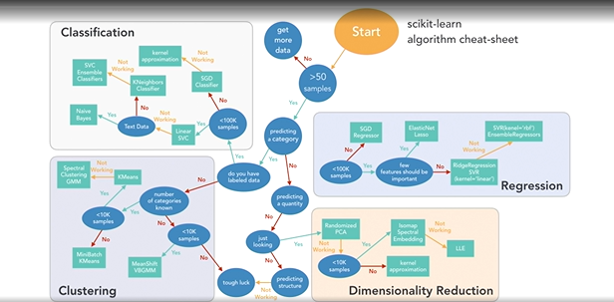

## **AWS AI Solutions**

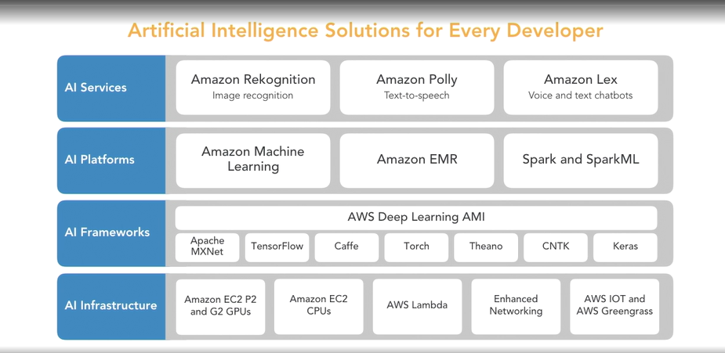

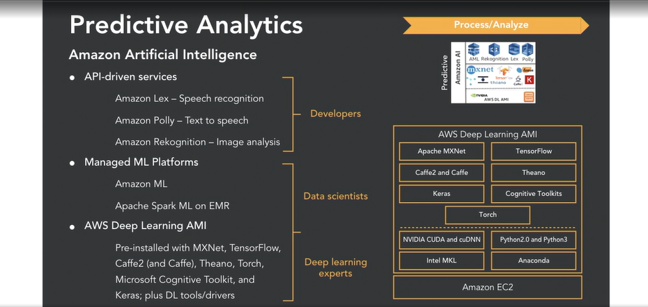

## **Which Analytics to use?**

1. Stream: MilliSeconds/Seconds-> Fraud Alerts?
2. Interactive: Seconds-> Self service dashboards?
3. Batch: Minutes/Hours-> Daily/Weekly/Monthly reports

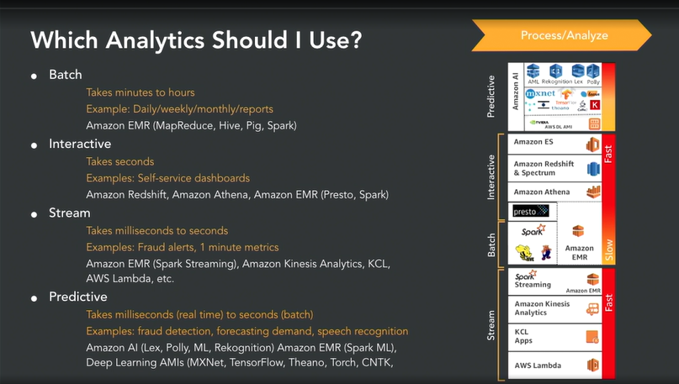

## **AWS MachineLearning API Services**

* Easy to use ML tools.
* Algorithms + AWS’s labelled data models.
* AWS Recognition:

Image labelling. For eg. Identify photos

* Supply input data and get predictions.
* Amazon Comprehend:

Supply data from social media posts, emails, webpages, documents, phone transcriptions(on Amazon)-> Comprehend API does NLP(automatically extracts key phrases, entities, sentiment, language, topics)->Extracted data and topics with confidence scores.

* Three categories:

1. Vision services- recognition
2. Conversational chatbots- lex
3. Language services- comprehend, translate, transcribe, polly

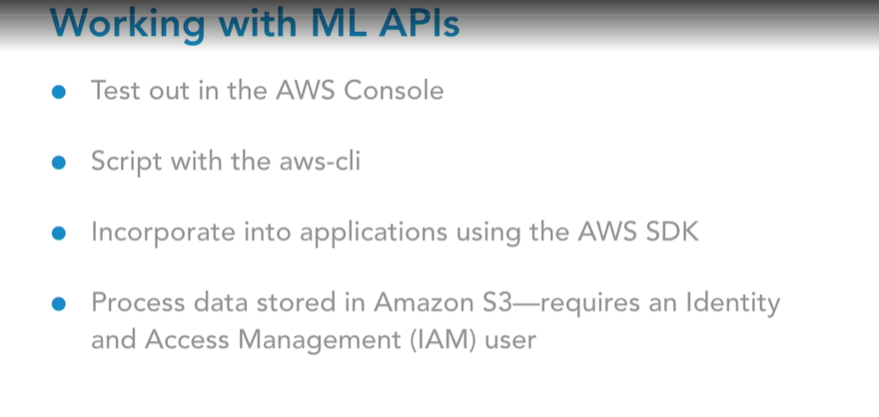

* Amazon Polly for Text to Speech:

Supports many languages

Supports many voices

Can customize with lexicon

Works with Speech Synthesis Markup Language(SSML)

Usecase:

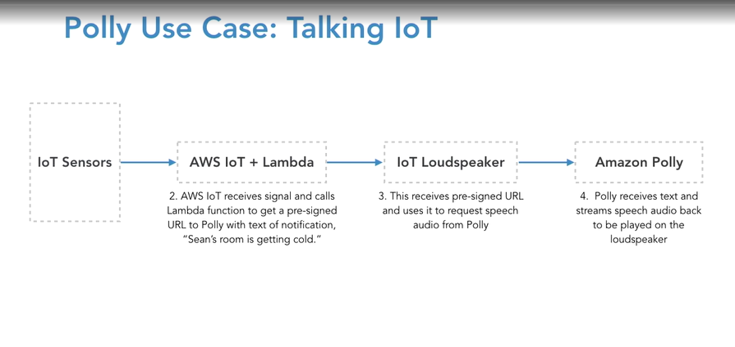

* Amazon Lex:

Used by Amazon Alexa

Used to create conversation interfaces(Chatbots)

Uses ML for both voice and texts

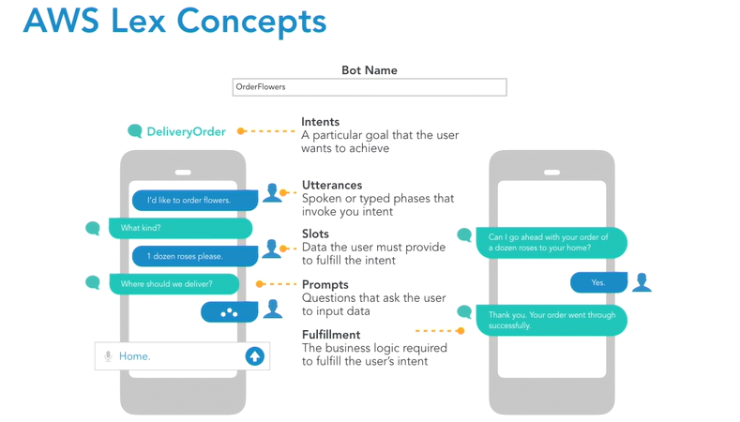

Usecase:

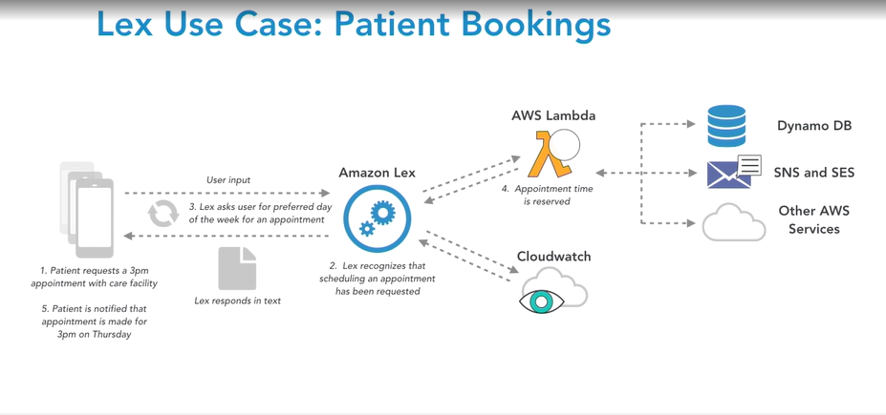

* Amazon Rekognition for images:

Can detect images and scenes

Can be used for ‘image moderation’

Can detect facial information and compare faces including celebrity faces.

Can detect text in images

* Amazon Rekognition for videos:

Can detcet object and activities

Can be used with moderated labels

* Amazon Transcribe:

Automatic voice recognition into text output

Can be used to timestamp audio files like .mp3 and .wav

* Amazon Translate:

Supports Natural language Translation

Languages: Arabic, Chinese, French, German, Portuguese, Spanish

Designed to integrate with Polly(speech output), S3(document repository translation), Comprehend(extract entities)

## **AWS MachineLearning Platforms**

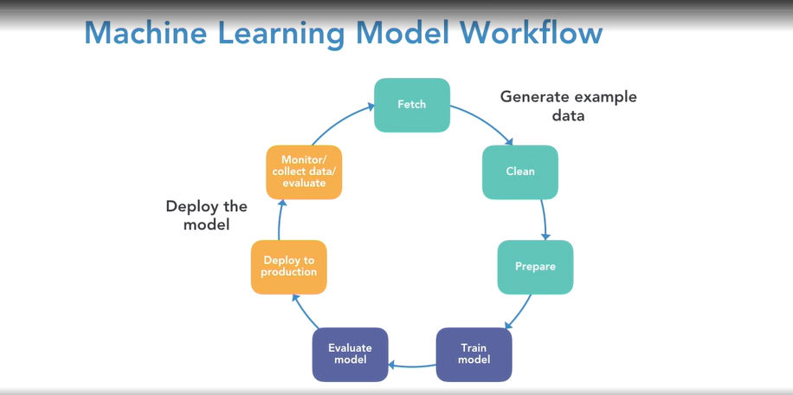

Expanded in below categories:

* Serverless or containers:

Supply your own training data and AWS picks the models- Amazon ML.

Supply data and pick(or create)model- Amazon SageMaker or ECS.

* + Amazon Machine Learning:

Includes 2 Prebuild machine learning models.

Suggests which algorithm to use based on input data.

Its integrated with S3.Amazon Redshift(data warehouse).

* + Amazon SageMaker:

Scalable ML.

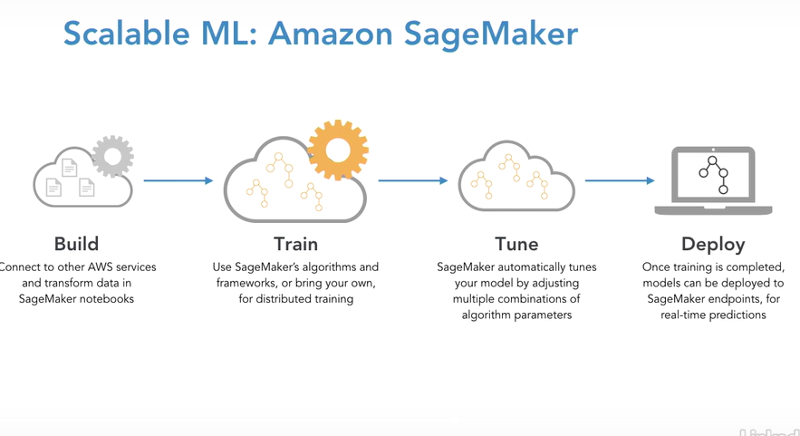

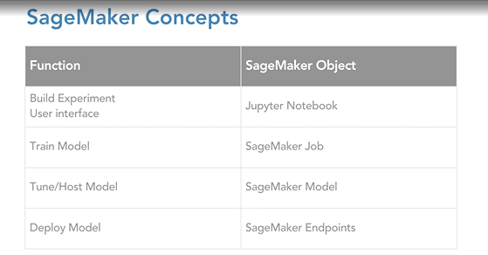

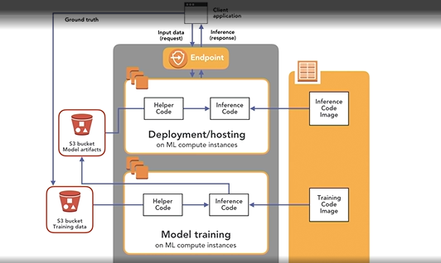

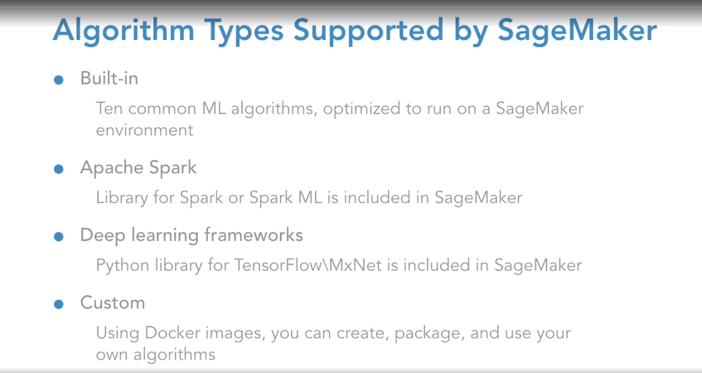

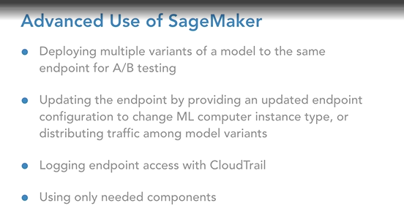

* AWS SageMaker resources:

1. [Amazon SageMaker Documentation](https://docs.aws.amazon.com/sagemaker/)
2. [Built-in algorithms and pretrained models in Amazon SageMaker - Amazon SageMaker AI](https://docs.aws.amazon.com/sagemaker/latest/dg/algos.html)

* Managed Virtual Servers:

Managed Spark/ Spark ML- Elastic Map Reduce(EMR)

AWS Batch- managed EC2 spots(fleets)

Vendor solution- Spark on Databricks

## **AWS MachineLearning Virtual Servers**

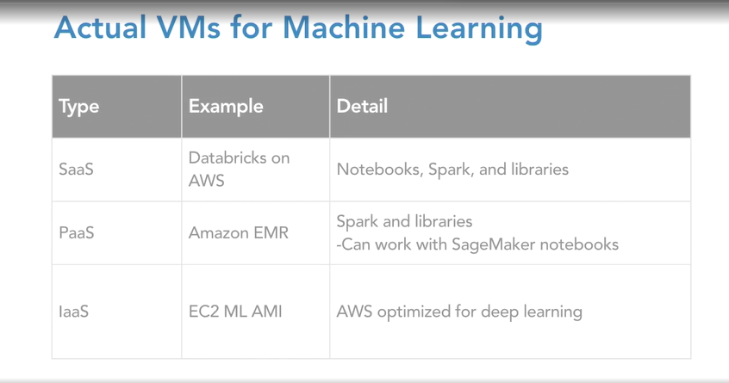

**Databricks on AWS:**

* Databricks offers apache spark-as-service. Cluster of virtual servers for machine learning. It provides optimized clusters of virtual servers.
* Databricks sample notebooks.
* Range of operation including ML.
* Free Databricks community edition.

Documentation:

[Databricks documentation | Databricks on AWS](https://docs.databricks.com/en/index.html)

**Amazon Elastic Map Reduce:**

* Managed Hadoop server clusters.
* Can install many libraries easily.
* Can run bootstrap tasks to further customize.
* Can utilize spot instance/fleets to optimize scaling(very useful while working with EMR).

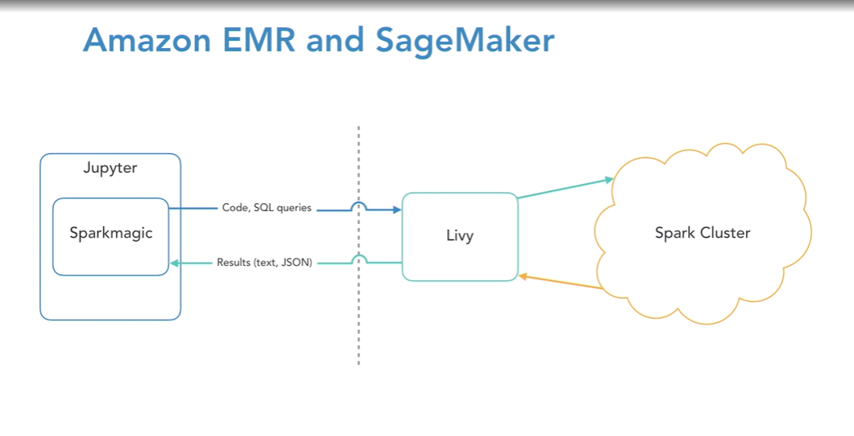

## **AWS MachineLearning Architectures**

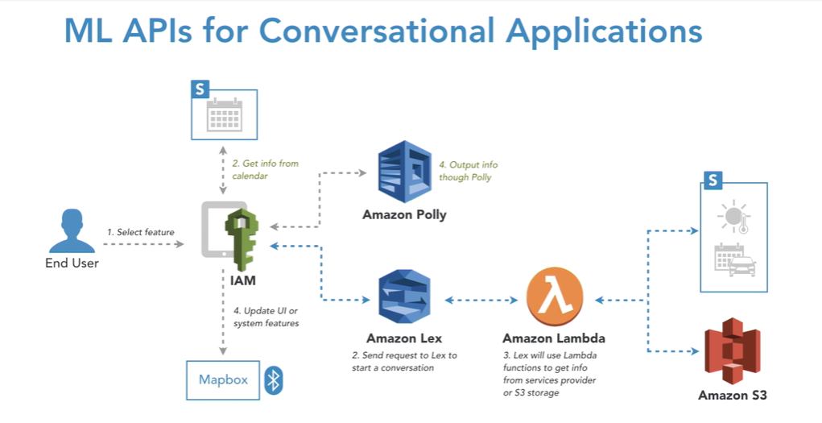

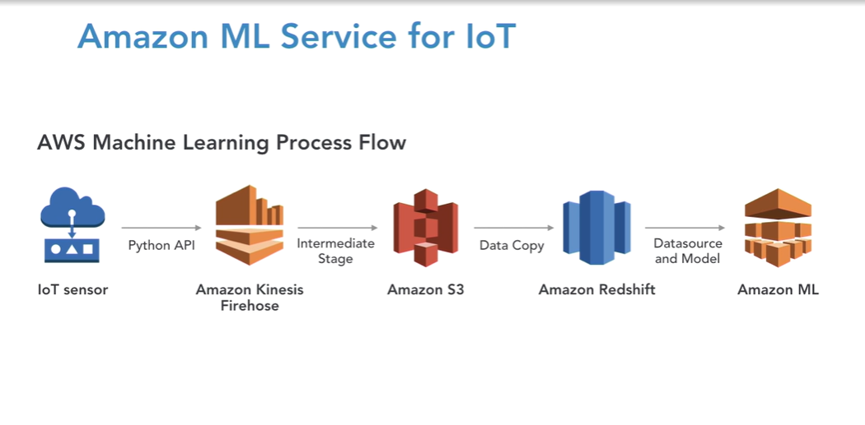

* Amazon kinesis firehose is fully managed data streaming service by AWS that delivers real time data to storage and analytics services. It is designed to capture, transform and load rela time data to various destinations like- Amazon S3, Amazon Redshift, Splunk, Amazon Opensearch service, Custom HTTP endpoints etc.

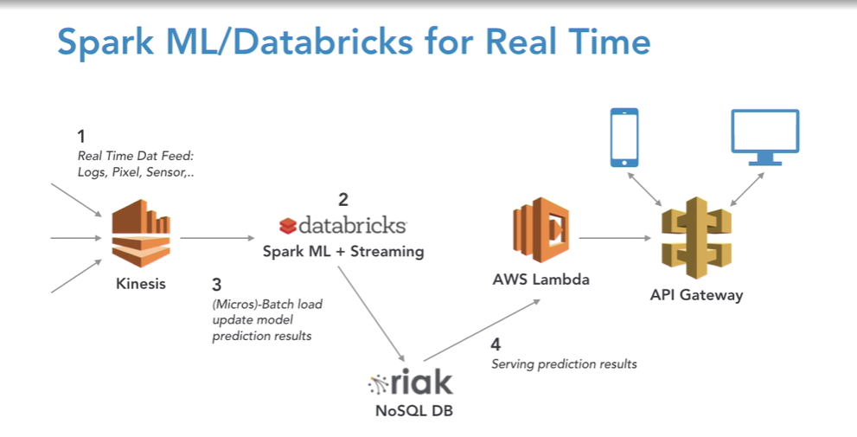

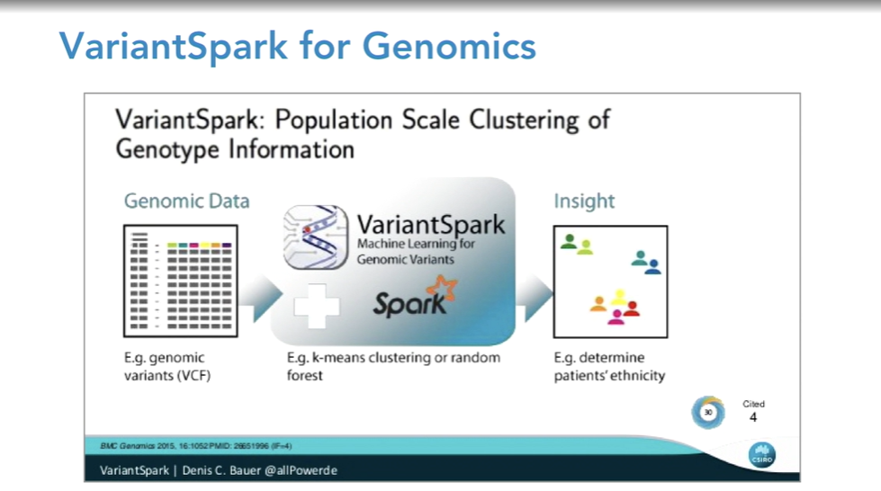

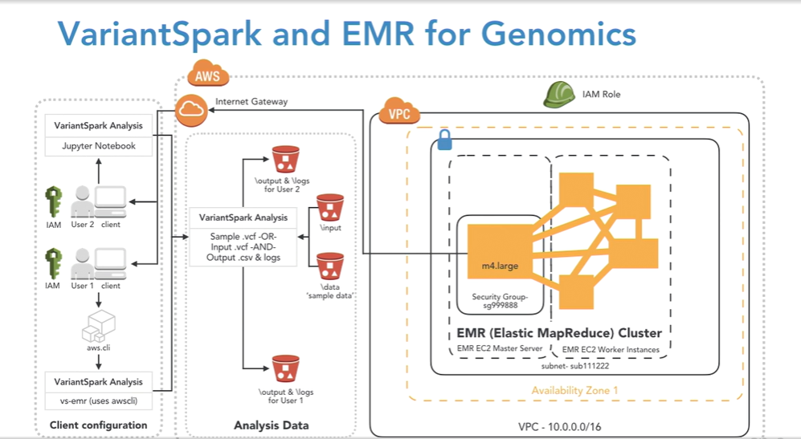

## **AWS MachineLearning Tips**

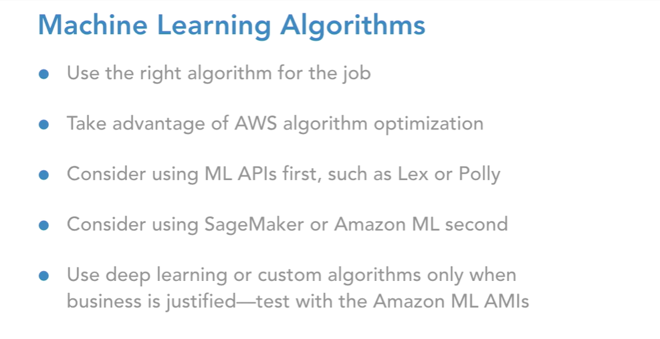

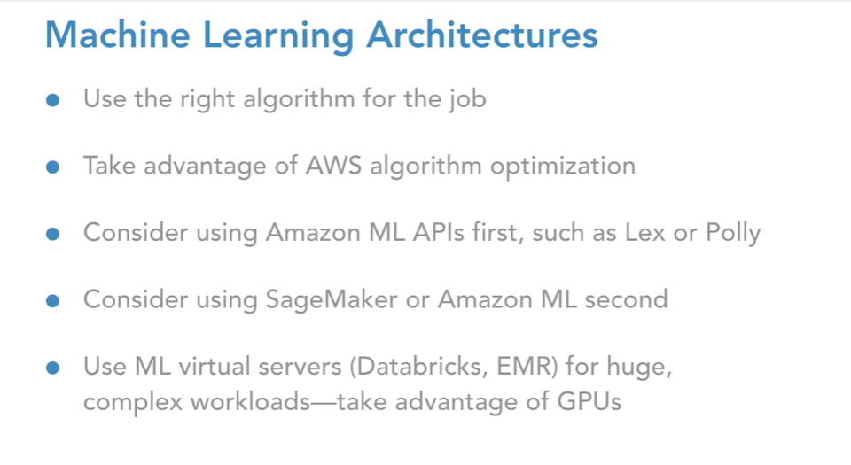

ML Resources:

<https://scikit-learn.org/stable/index.html>

[Machine Learning - KDnuggets](https://www.kdnuggets.com/tag/machine-learning)

[Kaggle: Your Machine Learning and Data Science Community](https://www.kaggle.com/)